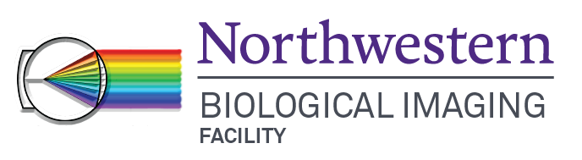
Leica SP5 Confocal Quick Start Guide

Initial Set-up
~ Log in to NUCore and start a reservation.
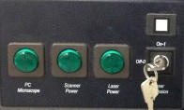
~ On Power control panel switch on Laser and Scanner power (A), then PC/Microscope button.
A
B
Power supply control panel
~ Turn laser power key (B) to “On”.
~ Turn on LED main power (behind monitor) and press control knob.
~ Log into computer, if necessary (TCS User; password: user).
~ Launch LAS software. Select Resonant Scanning, if applicable.
~ Ensure 10x objective is in place and say “OK” to initialize stage, when dialog appears.
~ Navigate to “Configuration” tab (C) and activate lasers, as appropriate.
~ For Argon laser, set power (~20-25% is usually a good start). Wait 10 min for lasers to warm up.
~ While waiting, put slide on scope and set up image acquisition.

Mount sample on microscope
~ Place slide on stage ‘coverslip down’.
~ For transmitted light imaging: Press TL/IL button on left side of microscope. Focus on a sample.
~ For fluorescent light imaging: Select filter cube from buttons on front of microscope (I3 – GFP, N2.1 – RFP, A – DAPI) and open shutter.
~ Focus on sample and find cell/region of interest. Close shutter.

Confocal imaging
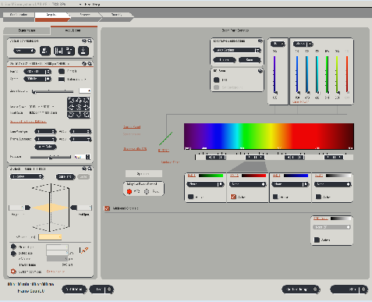
~ In software, navigate to “Acquire” tab (D).
LAS Software Interface
 |  |  |  |  | M
C | D
 | E
 | F
 | G
 |  | I |  |  |  | L
 |  |  | J | K
 | H

~ To set Beam Path Settings, first activate the laser(s) needed by clicking “Visible” (M) and setting laser intensities (10-20% to start).
~ Activate the HyD detector(s) or PMT(s) by selecting the “Active” button(s). Choose a color for the detector display by clicking the color bar (J) and selecting a LUT from the window that opens.
~ To display emission peak to guide detector settings, choose from list of common fluorophores (K).

~ Place the detector bar (L) in correspondence with the fluorophore emission by sliding right or left and resizing. Repeat for each detector.
~ Select the appropriate dichroic mirror by clicking the current dichroic and selecting from the drop down list (I).
~ Click the “Live” Button to check settings. View image as intensity values by selecting the Glow (OAU) LUT with the QLUT button.
~ Adjust Smart Gain so that there are mostly orange and white pixels and minimal blue (saturated) pixels. If necessary, adjust laser intensity or detector bar positions.
~ Click “Stop” then click “Capture Image” to acquire a single image.

Setting up a sequential scan.
~ If you are using the UV laser or have significant overlap between fluorophore emission, a Sequential Scan may be required. To get started, select the “Seq” button (E).
~ In the Sequential Scan window, click the (+) button until you have the desired number of scans present. Choose “Between Lines” “...Frames” or “...Stacks.” “Between lines” can only be used when the same dichroic is used in all scans.
~ Set up the laser and detector bars for each scan as appropriate for each fluorophore, following directions from #3 above. Changes made in one “Scan” will not affect those made in others.
~ Save settings for use in the future, if desired. Click “Save” in the “Sequential Scan” window.

Acquiring a Z-series
~ In the Acquisition tab (D), be sure “xyz” is selected under Acquisition Mode (F).
~ Move to the top of your sample with the Z position knob in Smart control bar and set the position by clicking the “Begin” arrowhead (H). Note: using focus knob on microscope or joystick will not adjust galvostage position for z-stack.
~ Move to the bottom of your sample with the Z position knob and set the position by clicking on the “End” arrowhead. Click “Stop”.
~ Set the desired number/size of z steps. To achieve Nyquist sampling, click on “Section Thickness” (G) and click “Apply settings” in the window that opens.
~ Ensure imaging settings are correct then hit “Start” to collect z stack.
~ The z-stack will be saved under the Experiment tab, as a Series00X file.

Save images
~ At the bottom of the Experiment tab, click “Save All”. Select the appropriate directory and change the Experiment file name, if desired.
~ Click OK to save.

Shut Down
~ Remove sample. Clean oil off objectives with lens paper. Return objective turret to 10x.
~ Transfer files to flash drive or network storage. Close software.
~ If there is another user within a 2-hour time period, stop here, leaving lasers and computer on. End reservation in NUCore. If not, proceed with following steps for complete shutdown.
~ Turn Laser key to “OFF”. Turn off the LED. Switch off the Scanner and Laser power buttons (A). Shut down the PC through Windows menu. Then turn off PC/Microscope switch on the control box.
~ Allow exhaust fan to run until it shuts off then switch Laser power (A) off.
~ Cover microscope. End reservation in NUCore.

If help is needed, please see BIF staff

